Access Recreation Group, LLC
Cindy Burkhour, MA, CTRS, CPRP
2454 Lamplighter Drive, Jenison, MI 49428-9127
Phone (616)669-9109 Mobile (616)560-2378
AccessRecreationGroup@juno.com

Otter Creek Trail Accessibility Information
Trail Head Location: Esch Beach road end
Date Assessed: 10/24 & 26/2015

Total Trail Length: 4.5 miles (23,895’)  section #1: 2.1 miles (11,217’)  section #2: 1.2 miles (6,715’)  section #3: 1.1 miles (5,963’) | Overall Barrier Descriptions
Surface:  section #1: packed earth with across trail roots  section #2: packed earth with across trail roots  section #3: packed earth road bed, ruts, center crown, across trail roots, rocks | Packed earth, cross trail roots, erosion rutting, roadway center crowning, encroaching vegetation
Tread Width:  section #1: Typical under 36” /Minimum 6”  section #2: Typical + 36” /Minimum 13½“  section #3: Typical + 8’ /Minimum 17” | single track narrowed by encroaching vegetation
Running Slope:  section #1: Typical under 5% /Maximum 17.3%  section #2: Typical under 5% / Maximum 13%  section #3: Typical under 5% / Maximum 10% | Intermittent steep slope up-hill & down-hill segments
Cross Slope:  section #1: Typical under 3% / Maximum 11.6%  section #2: Typical under 3% / Maximum under 3%  section #3: Typical under 3% / Maximum 25% | Road bed crowning/ruts with up to 25% cross slope in straight up/down hill segments with significant soil erosion

o** Slopes between 5% & 8.33% are equal to the slope on a ramp in the built environment

Feature  Barrier | 603’ | 112’ | 5% | 2  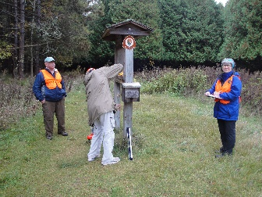 | Information Kiosk & Map Box:  Clear space surface is inaccessible grass  No accessible route from road
Feature  Barrier |  |  |  |  | Parking:  No parking at trail head, roadside only
Feature |  |  |  |  | Toilets:  None at trail head, nearest at Esch Beach road end, inaccessible design, not signed, not located on an accessible route
Feature |  |  |  |  | Potable Water: None
Barrier | 609’ | 0’ | 0% | 1  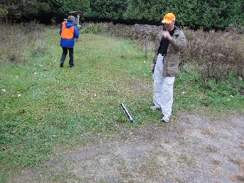 | Surface: inaccessible grass surface  Slope: steep slopes 11.4% & 17.3% at roadside ditch on route from road to information kiosk  Width: +36”
Feature | 163 | 115’ | 2% |  | Ski trail marker
Barrier | 164 | 71’ | 7% | 3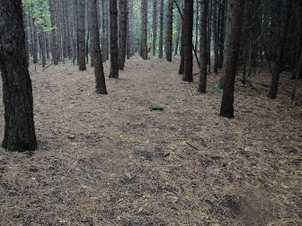 | Ski trail marker  Surface: packed earth, across trail roots  Slope: under 5%  Width: +36”
Barrier | 165 | 197 | 4% | 4  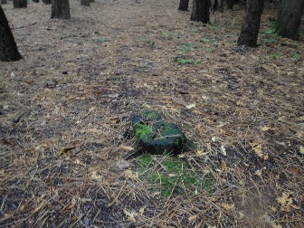 | Surface: packed earth, 3 mid-trail tree stumps  Slope: under 5%  Width: +36”
Feature | 166 | 140’ | 1% |  | Ski trail marker
Barrier  Feature | 167 | 81’ | 6% | 5  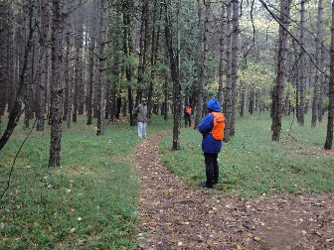 | Ski trail marker  Surface: packed earth  Slope: under 5%  Width: +36”, then narrows to 30’
Feature | 168 | 42’ | 0% |  | Ski trail marker
Feature | 169 | 27’ | 4% |  | Ski trail marker

Barrier  Feature | 170 | 114’ | 7% | 6  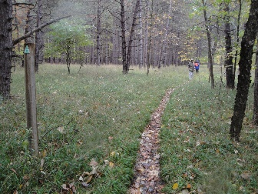 | Ski trail marker  Surface: packed earth  Slope: under 5%  Width: trail narrows further to 21’’ @632’
Barrier  Feature | 171 | 92’ | 11% | 7  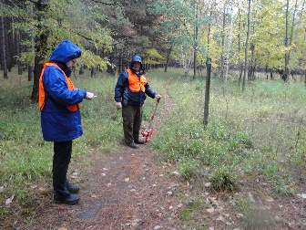 | Ski trail marker  Surface: packed earth  Slope: under 5%  Width: trail narrows further to 12’’ @731’
Barrier  Feature | 172 | 227’ | 0% | 8  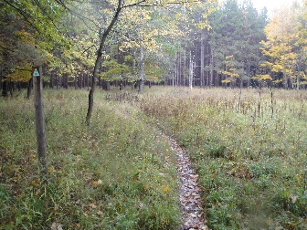 | Ski trail marker  Surface: packed earth  Slope: under 5%  Width: trail narrows further to 7”, significant single track rutting
Barrier  Feature | 173 | 90’ | 0% | 9  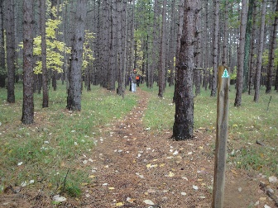 | Ski trail marker  Surface: packed earth covered with pine needles  Slope: under 5%  Width: trail widens to 18½”
Feature | 174 | 181’ | 1% |  | Ski trail marker
Feature | 175 | 78’ | 9% |  | Ski trail marker
Barrier  Feature | 176 | 77’ | 5% | 10  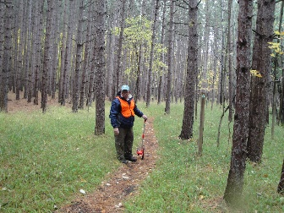 | Ski trail marker  Surface: packed earth, pine needles (slippery when wet)  Slope: under 5%  Width: narrows to 12”
Barrier  Feature |  |  |  | 11  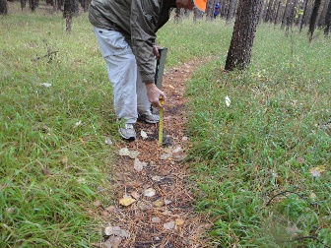 | Surface: packed earth, across trail roots  Slope: under 5%  Width: +36”

Barrier  Feature | 177 | 116’ | 14% | 12  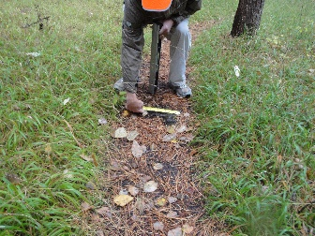 | Ski trail marker  Surface: packed earth  Slope: under 5%  Width: narrows to 17”
Barrier  Feature | 178 | 150’ | 3% | 13  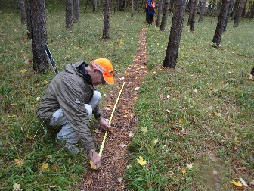 | Ski trail marker  Surface: packed earth, across trail roots for 6’  Slope: under 5%  Width: under 17”
Barrier  Feature | 179 | 107’ | 3% | 14  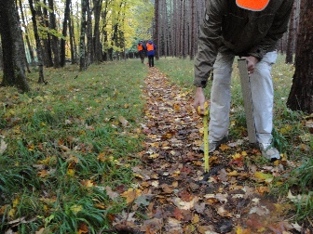  15  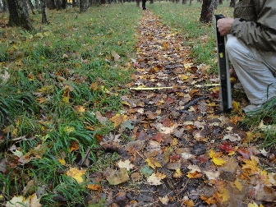 | Ski trail marker  Surface: packed earth, across trail roots  Slope: under 5%  Width: widens to 24”
Barrier  Feature | 180 | 111’ | 1% | 16  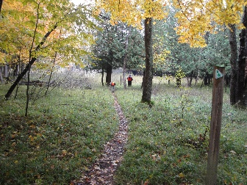 | Ski trail marker  Surface: packed earth  Slope: under 5%  Width: under 36”

Barrier  Feature | 181 | 97’ | 1% | 17  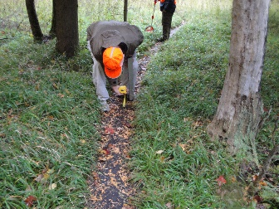  18  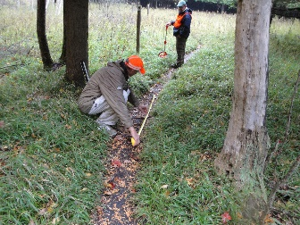 | Ski trail marker  Surface: packed earth, across trail roots (for 8’)  Slope: under 5%  Width: narrows to 12”, encroaching vegetation
Barrier  Feature | 182 | 66’ | 0% | 19  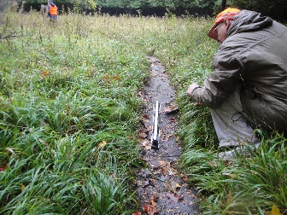  20  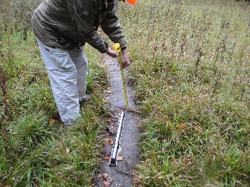  21  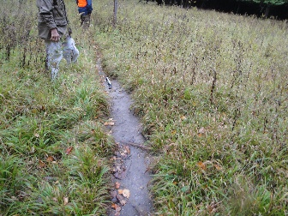 | Ski trail marker  Surface: packed earth/muddy, multiple across trail roots  Slope: 13.5%, 10.9%, 14.6%  Width: continues at 12”, encroaching vegetation
Barrier  Feature | 183 | 86’ | 0% | 22  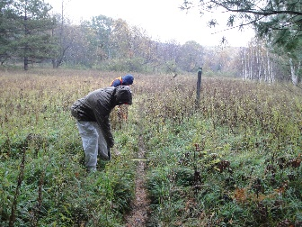 | Ski trail marker  Surface: packed earth  Slope: under 5%  Width: narrows to 6”, encroaching vegetation

Barrier  Feature | 184 | 105’ | 3% | 23  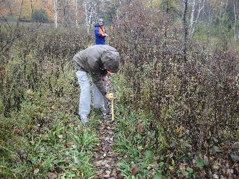 | Ski trail marker  Surface: packed earth  Slope: under 5%  Width: continues at 6”, encroaching vegetation
Barrier  Feature | 185 | 282 | 1% | 24  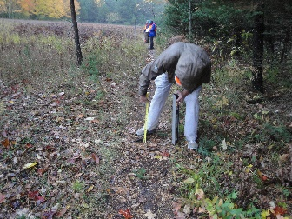  25  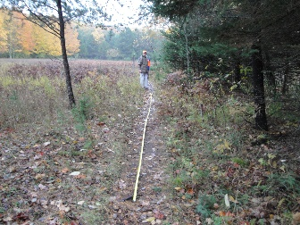 | Ski trail marker  Surface: packed earth/muddy, multiple across trail roots  Slope: under 5%  Width: widens to 12”, encroaching vegetation
Barrier  Feature | 186 | 213’ | 0% | 26  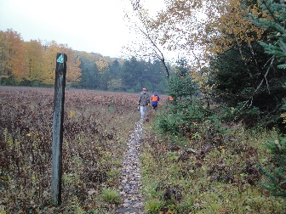 | Ski trail marker  Surface: packed earth/muddy, multiple across trail roots  Slope: under 5%  Width: continues at 12”, encroaching vegetation
Barrier  Feature | 187 | 123’ | 1% | 27  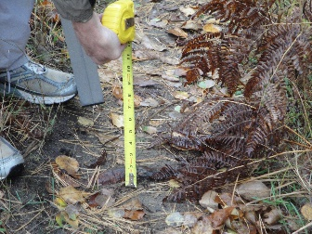  28  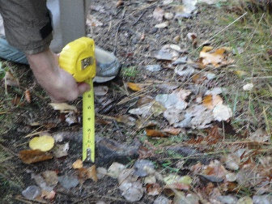 | Ski trail marker  Surface: packed earth, across trail roots  Slope: under 5%  Width: continues at 12”, encroaching vegetation

Barrier  Feature | 188 | 328’ | 2% | 29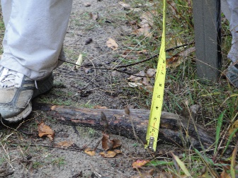 | Ski trail marker  Surface: packed earth, across trail roots + 3½”  Slope: under 5%  Width: continues at 12”, encroaching vegetation
Feature | 189 | 234’ | 0% |  | Ski trail marker
Barrier  Feature | 190 | 343’ | 2% | 30  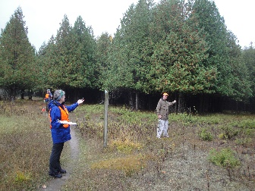 | Ski trail marker  Surface: packed earth  Slope: under 5%  Width: continues at 12”, encroaching vegetation
Barrier | 191 | 169’ | 1% | 31  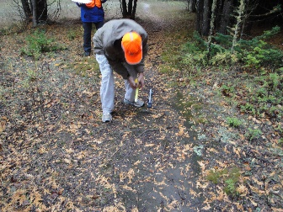  32  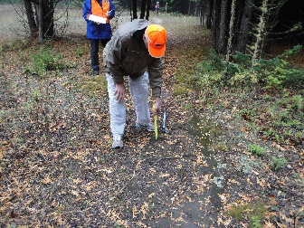 | Ski trail marker  Surface: packed earth, cross trail roots (cedar trees)  Slope: under 5%  Width: widens to 18”
Barrier  Feature | 192 | 116’ | 2% | 33  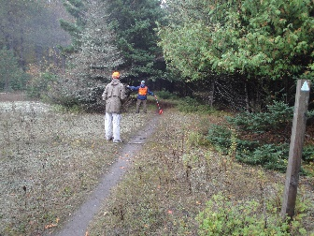 | Ski trail marker  Surface: packed earth, cross trail roots (cedar trees)  Slope: under 5%  Width: continues at 18”

Barrier  Feature | 193 | 528’ | 4% | 34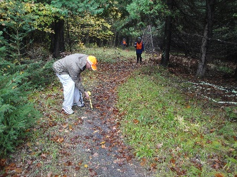  35  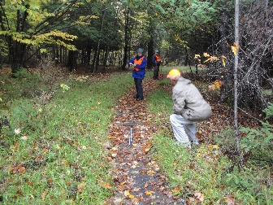 | Surface: packed earth, changing to crush/fines @ 4000’, very large & many cross trail roots (cedar trees), crowned surface for 42’  Slope: up to 7% - 11.2%  Width: begins at 18” then widens to 72”
Barrier  Feature | 194 | 248’ | 0% | 36  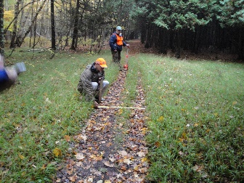 | Ski trail marker  Surface: packed earth, cross trail roots  Slope: up to 11.2% (for 24’)  Width: @ 4593’ narrows dramatically, double crowning ends @ 4694
Barrier  Feature | 195 | 1056’ | 0% | 37  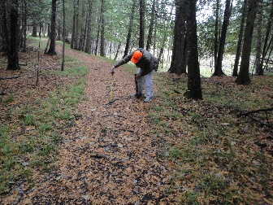  38  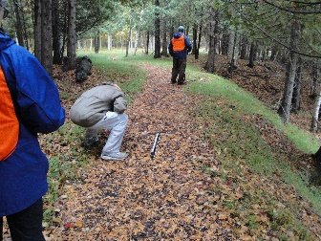 | Ski trail marker  Surface: packed earth, multiple crowns for 36’, multiple large across trail roots  Slope: under 5%  Width: widens to 21”

Barrier  Feature | 196 | 1056’ | 0% | 39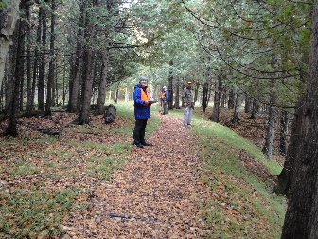  40  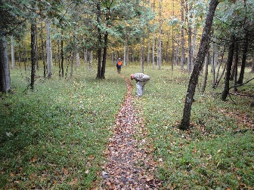 | Ski trail marker  Surface: packed earth, multiple large across trail roots  Slope: under 5%  Width: narrows to 10”, then 7”
Barrier  Feature | 197 | 1056’ | 0% | 41  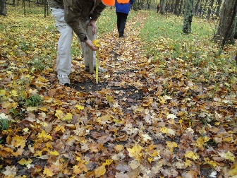  42  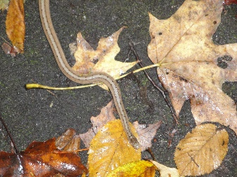 | Ski trail marker  Surface: packed earth, multiple large across trail roots +3”  Slope: under 5%  Width: widens to 18”, host to one very cool snake (see photo!)
Barrier  Feature | 198 | 170’ | 15% | 43  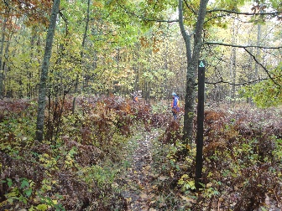 | Ski trail marker  Surface: sandy soil, very large ferns  Slope: under 5%  Width: narrow single track 6”, encroaching vegetation
Barrier  Feature | 199 | 204’ | 15% |  | Ski trail marker  Surface: packed earth  Slope: under 5%  Width: remains narrow 6”
Barrier  Feature | 200 | 216’ | 0% | 44  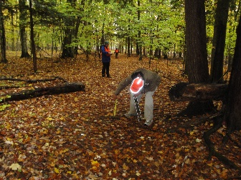 | Ski trail marker  Surface: packed earth, cross trail roots  Slope: under 5%  Width: +36”

Barrier  Feature | 201 | 130’ | 1% | 45  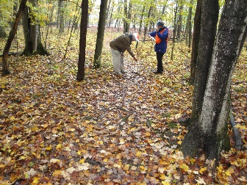 | Ski trail marker  Surface: packed earth, some loose/soft sand  Slope: under 5%  Width: narrows to 18”
Barrier |  |  |  | 46  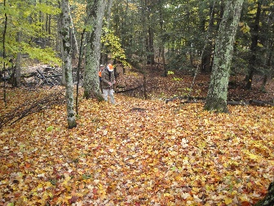  47  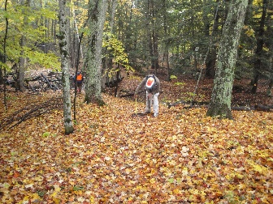  48  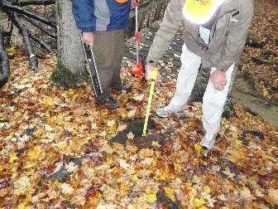 | Surface: packed earth multiple large across trail roots +2” - +4”  Slope: up to 14.6% with cross slopes up to 11.6% on approach to bridge  Width: +36”

Barrier  Feature |  |  |  | 49  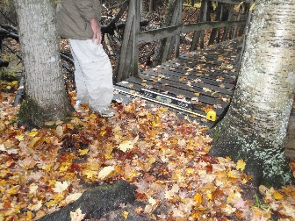  50  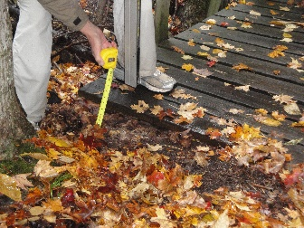  51  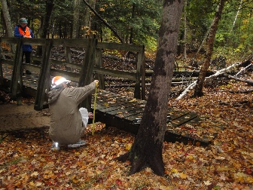 | Surface: boardwalk bridge, 6” change of level onto bridge  Slope: under 5%  Width: 45” w/16” drop-off w/out edge protection at ramped exit from the bridge
Barrier  Feature | 202 | 205’ | 0% |  | Ski trail marker  Surface: packed earth  Slope: 12.3%, 8.7%, 7.5%  Width: +36”
Barrier  Feature | 203 | 172’ | 4% |  | Ski trail marker  Surface: packed earth  Slope: under 5%  Width: narrows to 6”, encroaching vegetation

Barrier  Feature | 204 | 1056’ | 0% | 52  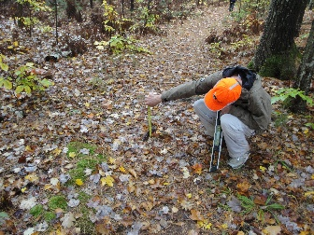  53  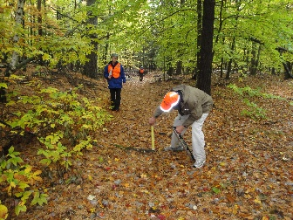  54  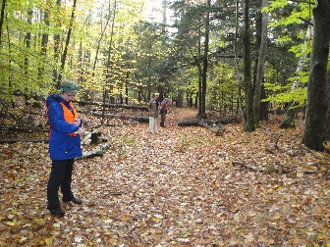  55  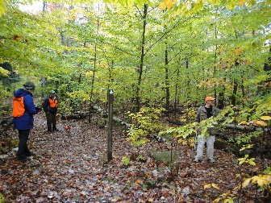 | Ski trail marker  Surface: packed earth, multiple across trail roots +1½”, +2½”, +3½”  Slope: under 5%  Width: widens to +36”, social trail inter section

Barrier  Feature |  |  |  | 56  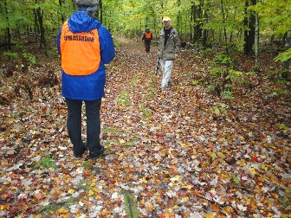  57  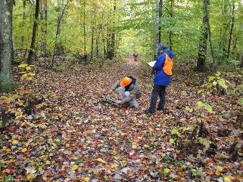  58  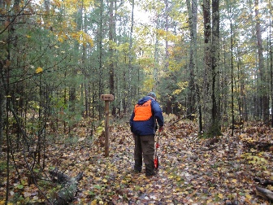 | Surface: packed earth, mossy crowning, multiple across trail roots 2½”, +3½”  Slope: under 5%  Width: +36”
Section #2
Barrier  Feature | 205 | 1214’ | 0% | 61  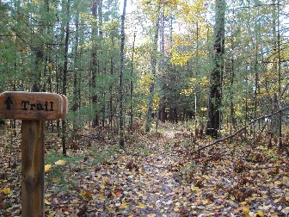 | Surface: packed earth  Slope: 11.4%  Width: 13½”
Barrier | 206 | 57’ | 25% | 62  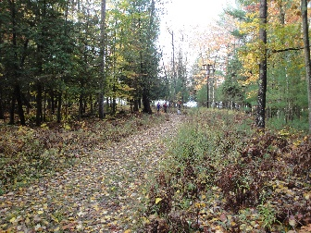  63  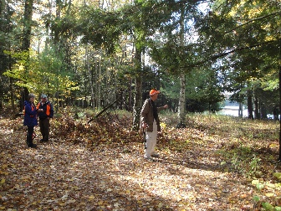 | Surface: packed earth, crowned road bed  Slope: under 5%  Width: +60”

Barrier  Feature | 207 | 154’ | 6% | 64  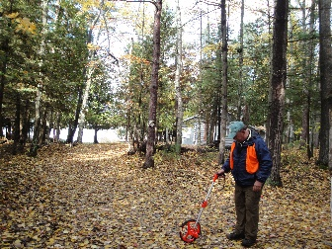 | Ski trail marker  Surface: packed earth  Slope: under 5%  Width: +60”
Barrier  Feature | 208 | 897’ | 0% | 65  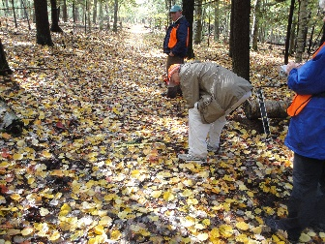  66  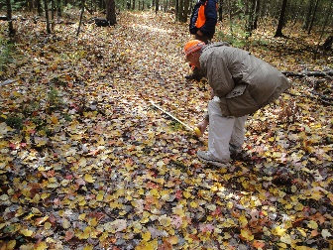  67  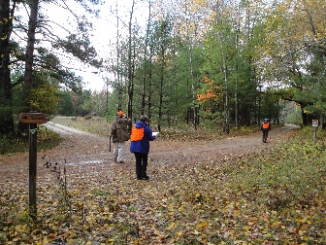 | Trail sign  Surface: packed earth, mid-trail stumps at 708’ & 972’  Slope: under 5%  Width: +60” narrows to 40” at 1117’

Barrier  Feature | 209 | 792’ | 0% | 68  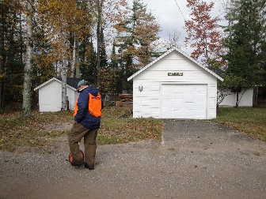  69  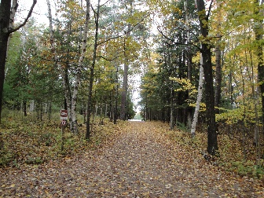  70  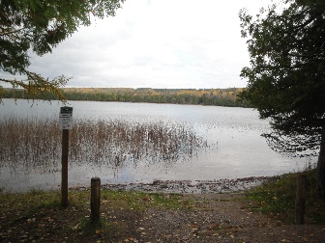  71  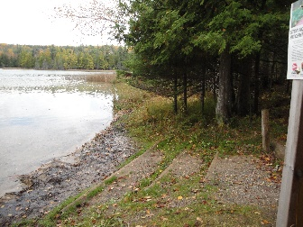 | Ski trail marker  Surface: packed earth & gravel road bed,  Slope: under 5%  Width: +9½’  Cabin at 1479’; boat launch carry down site & lake access at 1941’

Barrier  Feature | 210 | 1050’ | 0% | 72  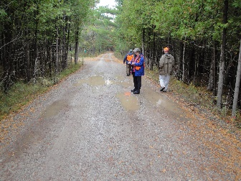  73  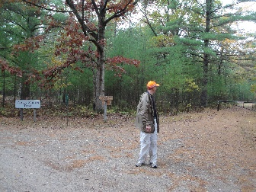  74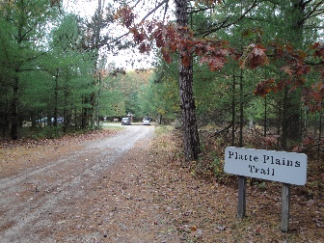  75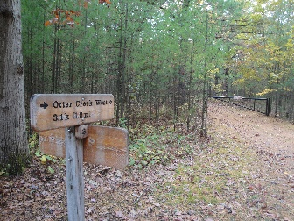  76  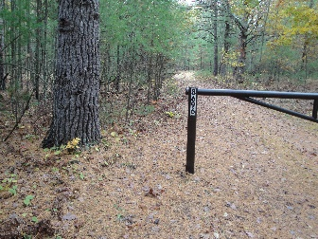  77  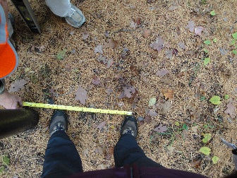 | Trail intersection to trail gate  Surface: packed earth & gravel road bed with washouts  Slope: under 5%  Width: +9½’, narrows to 17” between gate post & tree
Barrier  Feature | 211 | 320’ | 3% |  | Ski trail marker  Surface: packed earth & crowned gravel road  Slope: under 5%  Width: +7½‘

Barrier  Feature | 212 | 236’ | 0% | 78  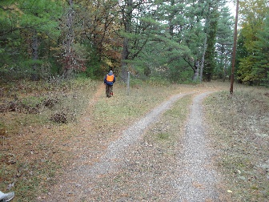 | Ski trail marker  Surface: changes to packed earth, crush/fines begin at 3193’ & ends at 3400’.  Slope: 8%, 6.6%, 11.9%  Width: narrows to 36”
Barrier |  |  |  | 79  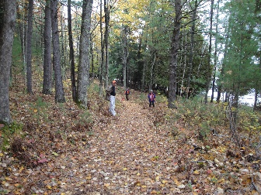 | Surface: packed earth, rolling terrain, across trail roots  Slope: 11.9%, 9.1%, 7.2%, 11%, 7.2  Width: +36”
Barrier |  |  |  | 80  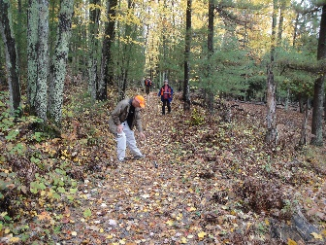 | Surface: packed earth, rolling terrain  Slope: 9.1%, 13%, large dip at 3906’  Width: +36”
Barrier  Feature | 213 | 1320’ | 0% | 81  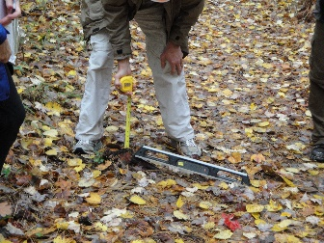  82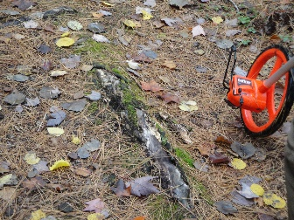  83  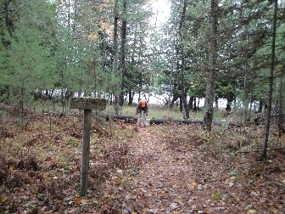 | Surface: packed earth, across trail roots +4½“ & 3½“  Slope: under 5%  Width: +36”, narrows to 21” at 4683’  Social trail to Otter Lake, route reduced to 25” through downed tree cut-out
Feature | 214 | 528’ | 0% |  | Ski trail marker

Barrier  Feature | 215 | 1478’ | 0% | 84  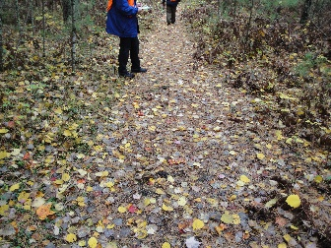  85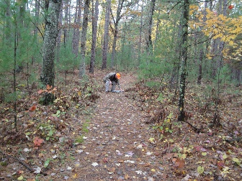  86  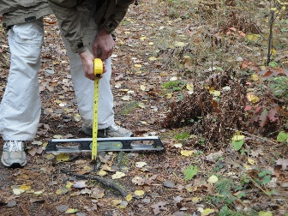  87  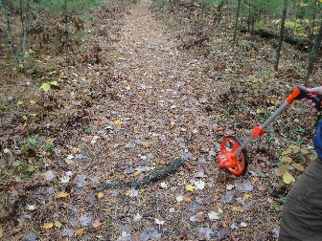  88  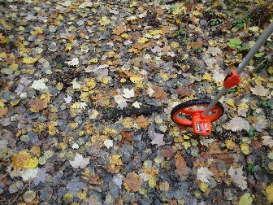  89  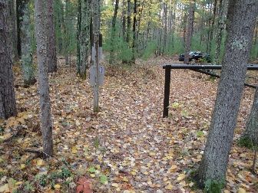  90  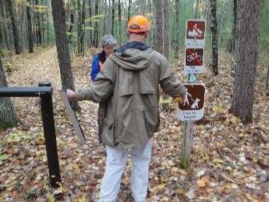 | Surface: packed earth, multiple segments of across trail roots +2”  Slope: under 5%  Width: continues at 21” to trail end at gate
Section #3
Barrier |  |  |  | 1  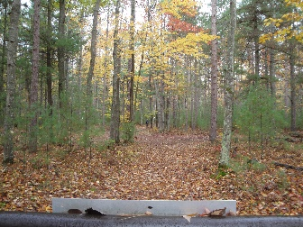 | Surface: packed earth road bed, ruts, center crown  Slope: under 5%  Width: +8’
Barrier  Feature | 216 | 1584’ | 0% | 2  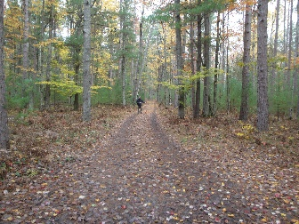  3  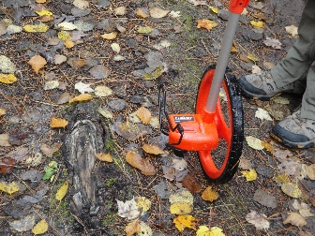 | Ski trail marker  Surface: packed earth road bed, ruts, center crown, across trail roots  Slope: under 5% w/cross slopes up to 25.5% due to crowning/ruts  Width: +8’
Barrier | 217 | 4224’ | 0% | 4  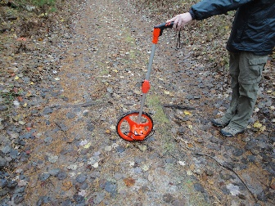  5  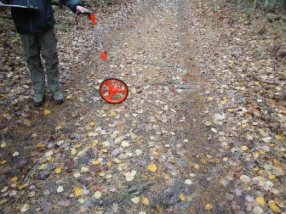 | Surface: packed earth road bed, gently rolling hills, a few across trail roots & some crowning  Slope: under 5%  Width: +8’

Barrier |  |  |  | 6  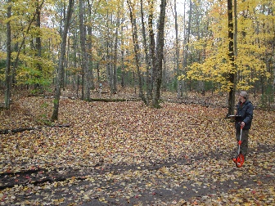 | Surface: packed earth road bed, ruts, center crown, across trail roots, rocks  Slope: 10%, 6.5%, 5%, 9.5%, 7%  Width: +8’
Barrier |  |  |  | 7  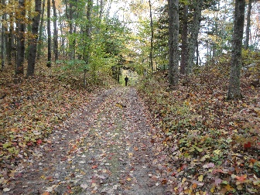  8  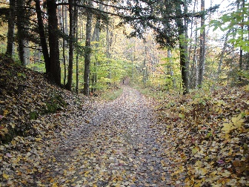  9  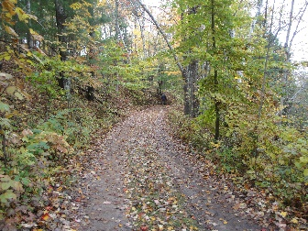 | Surface: packed earth road bed, ruts, center crown, across trail roots, rocks  Slope: 8%, 7.5%  Width: +8’

Barrier | 218 | 301’ | 0% | 10  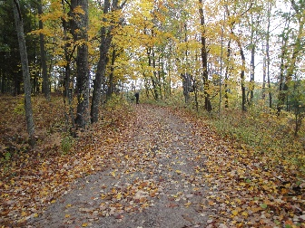  11  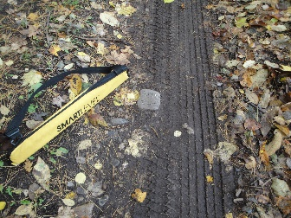  12  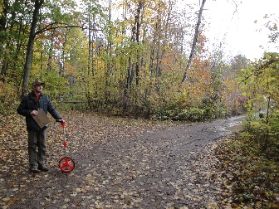 | Surface: packed earth road bed, ruts, center crown, across trail roots, rocks  Slope: under 5%  Width: +8’
Barrier |  |  |  | 13  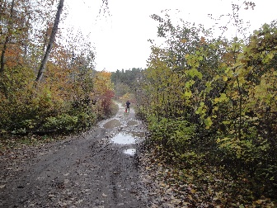  14  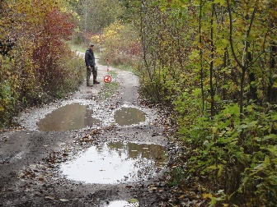 | Surface: packed earth road bed, deep ruts, ponding water, center crown, across trail roots, rocks  Slope: under 5%  Width: +8’

Barrier |  |  |  | 15  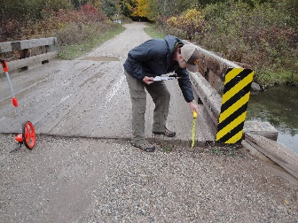  16  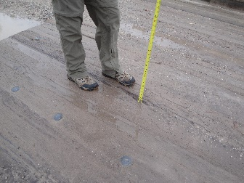 | Surface: wood surfaced bridge, 4” change of level onto bridge  Slope: under 5%  Width: +8’
Barrier |  |  |  | 17  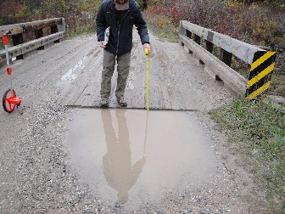 | Surface: wood surfaced bridge, 3” change of level off bridge  Slope: under 5%  Width: +8’

